

Satoru Akiyama (秋山悟)

Full Stack Developer

 Tokyo, Japan

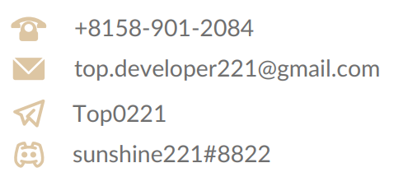

Experienced Web Developer who is adept in all stages of advanced web development.  
Knowledgeable in a user interface, testing, and debugging processes. Bringing forth expertise in the design, installation, testing, and maintenance of web systems. Equipped with an adverse and promising skill-set. Proficient in an assortment of technologies, including PHP, JavaScript, Node, TypeScript, React, Vue, Laravel, Python, Java, JSP, HTML/CSS, MySQL, Oracle, MongoDB, and Microsoft SQL Server. Able to effectively self-manage during independent projects, as well as collaborate in a team setting.

Projects



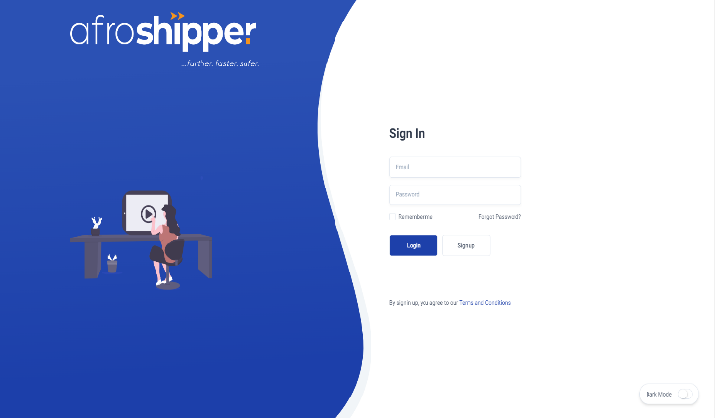

# Laravel + Vue + MySQL

This is a shipping platform, which provides shipping invoices.

<https://www.app.afroshipper.com>

# 

# React + Laravel + AWS

Atelier.M is an artisanal workshop dedicated to the creation and construction of unique and custom-made Metalwork and Locksmithing.

<https://www.atelier-metal.com>

# 

# NextJS + NodeJS + AWS

This platform is a service website that serves the new shampoo, and how to use and  
refill the club, the advantages, and disadvantages of hair management.

[https://www.hairstory.com](http://www.hairstory.com)

# React + Express + TailwindCSS

Mishmash was built on a deep passion for everything office.

https://www.mishmash.pt

# 

# React + Express + Payment Integration

Nobull is a Multi-purpose Fitness service. There are many services for Sportsmen  
and women such as E-Shop, global store network, training guide, refer a friend,  
Nobull tv, Nobull digital gift card, etc.

<https://www.nobullproject.com>

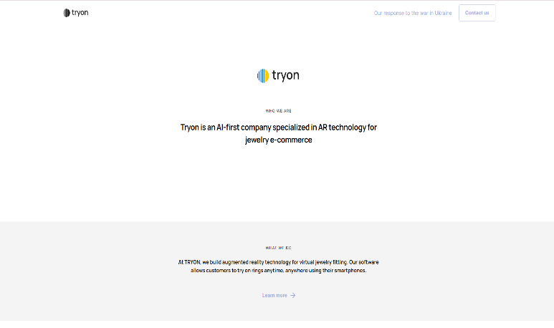

# Angular + Zone.js + BootStrap

This is a platform that provides Augmented Reality(AR) for Jewelry. As we know, jewelry is the best concern for women, so they want to see the beautiful jewelry ring with their fingers.

https://tryon.jewelry

# Laravel + Livewire + MySQL + Mongo

Rouillard is a website that serves a lot of modern and comfortable furniture for workspaces and offices.

<https://rouillard.ca>

# 

# Angular + Laravel + MySQL + SCSS

Saints & Stars is the only premium boutique gym where everything is focused on  
creating a perfect flow to achieve the next level of fitness and be part of a  
like-minded community of highly ambitious people.

<https://www.saints-stars.com>

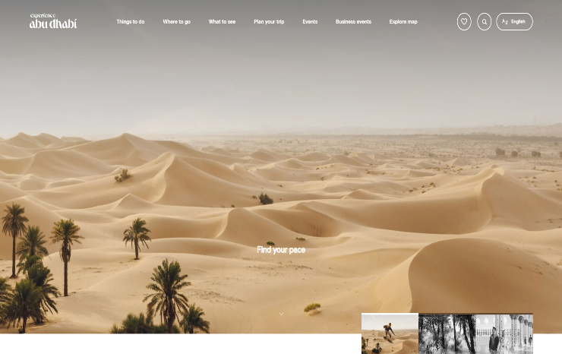

# ASP.NET + React + MSSQL

This is a travel Abu Dhabi platform, which provides the introduction of famous  
areas, cultures, things, events, shopping, nature, adventure, arts and lifestyle, and  
business, etc.

<https://visitabudhabi.ae>

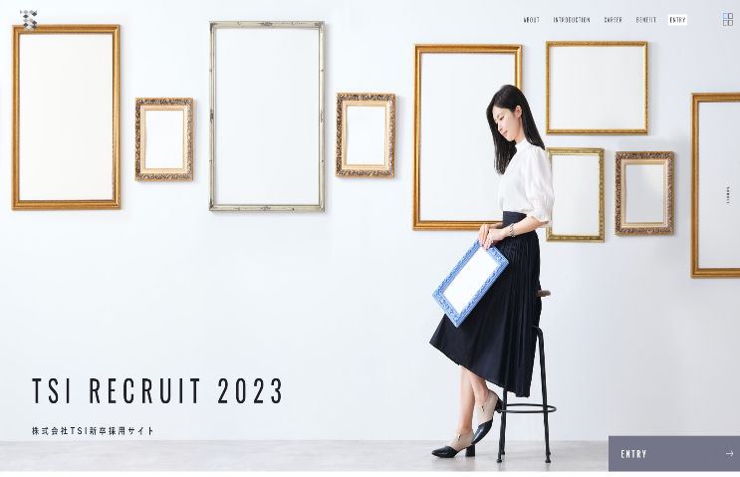

# Gatsby + React + Bootstrap + SCSS

TSI runs the products and stores full of originality while demonstrating its individuality by group companies that have many diverse brands such as EC business, sales agency business, restaurant business and so on.

<https://www.tsi-holdings.com/freshers>



# Skills

# ● Project Estimations, Requirements Gathering, UI/Function Improvement, ● Code Versioning/Debugging, Flexible Adaptable, Cultural Awareness, ● Project Management, Solutions Deployment, Web Security, ● Database Design/Programming, SQL Integration ● Frontend/Backend Development, Website Optimization, ● JavaScript, Node, Express, React, Vue, TypeScript, ● PHP, Laravel, Symfony, CodeIgniter, ● Python, Django, Flask, ● HTML/HTML5, CSS/CSS3/SCSS, Bootstrap, Vuetify, Material, Tailwind, ● MySQL, PostgreSQL, MS-SQL, MongoDB, SQLite, ● Java, JSP, Spring, Spring-MVC, Spring Boot, Struts, Hibernate, ● Blockchain, Solidity, NFT, Web3.js, ● AWS, EC2, Lambda, S3, Azure, Cloudways, CPanel, FastPanel

# Work Experience



## Freelance Software Engineer

### Upwork

Mar 2010 - Present (12 years 4 months +)

-Developed responsive web applications with frontend * backend framework options(HTML, CSS, Javascript, jQuery, Typescript, Angular, React, Vue, Ruby/Ruby on Rails, Node.js/Express, PHP/ Laravel/WordPress)

-Developed cutting-edge/robust mobile applications using React Native, Flutter

-Built +15 websites & +5 mobile applications for 10 to 15 individual clients and startups

## Software Engineer (Ruby, Node.js, React, React Native) - Remote

### 1ST NATIONS MORTGAGE CORPORATION

Apr 2020 - Nov 2021 (1 year 8 months)

*Maintained multiple live websites & mobile apps developed using Ruby and Node.js, React.js and ReactNative

*Ensured that all websites are bug-free and easy to use.

## Software Engineer II (Ruby on Rails) - Remote

### TourMega

Apr 2018 - Feb 2020 (1 year 11 months)

-Developed a search engine dedicated to tours and activities around the world.

-Integrated Google Maps api, Stripe payment gateway, Facebook apis

-Developed admin dashboard to manage users, bookings

-Developed a messaging app using Socket.io

## MERN Stack Developer (Node.js/MongoDB/React) - Remote

### Legably

Aug 2017 - Mar 2018 (8 months)

Developed a job market platform in Node.js with MongoDB and React.js. Created the "Payment Integration" using Chargebee

Integrated Stripe API to make payments

Developed admin dashboard to manage users, projects Developed a messaging app using Socket.io

## Software Engineer (Ruby on Rails) - Remote

### CoinFalcon

May 2016 - Jun 2017 (1 year 2 months)

Served as the RoR front-end developer for the front-end development of the coinfalcon.com website launched in early 2016.

The build system itself was developed in Ruby and used a listener thread to pull jobs from the PostgreSQL database when they were entered from the website. The website was a full-stack application built on Ruby on Rails and ES2016

## Full-stack Software Engineer - Remote

### Almosafer

Feb 2014 - Jan 2016 (2 years)

-Built the first generation of Almosafer website & mobile iOS/Android app

-Served as the architect and technical lead for the front-end development of the Almosafer hotel booking website & mobile application in early 2014.

## Freelance Frontend Developer

### Upwork

Mar 2010 - Apr 2014 (4 years 2 months)

-Learned fron-end technogical options (HTML, CSS, Javascript, and more)

-Developed responsive web applications with Javascript and AngularJS

-Built +10 various websites like Ecommerce, Social Dating, Productivity, Real Estate, Education businesses for 10 to 15 individual clients and startups

# Education



## The Education of University in Hong Kong, Bachelor’s degree

### Computer / Information Technology 5 years graduation. 2010-2014

Graduation Thesis:

“Study on Distortion Correction of Camera Image and Projection Image in

Multi-Projection System”

## Tokyo Institute of Technology

### Computer / IT Engineering 2 years graduation. 2015-2016

Graduation Thesis:

“Detection of the point of impact in the target by point to point”

# Training Courses



* JavaScript Web Projects: 20 Projects to Build Your PortfolioUdemy - 2017  
  ● 20 projects with pure JavaScript, HTML5, CSS3 with all code provided  
  ● Go from a total experter to a confident JavaScript developer.  
  ● Learned UI/UX practices to build responsive and mobile-first web applications
* NodeJS-The Complete Guide(MVC, REST APIs, GraphQL, Deno)  
  Udemy - 2018  
  ● Worked with one of the most in-demand web development programming languages.  
  ● Build modern, fast, and scalable server-side web applications with NodeJS, databases like SQL or MongoDB, and more.  
  ● Learned the basics as well as advanced concepts of NodeJS in great detail.  
  ● Understood the NodeJS ecosystem and build server-side rendered apps, REST APIs, and GraphQl APIs
* React-The Complete Guide(incl Hooks, React, Router, Redux)Udemy - 2018  
  ● Learned to build powerful, fast, user-friendly, and reactive web apps.  
  ● Learned all about React Hooks and React Components.
* Python for Beginners: Learn Python Programming(Python 3)Udemy - 2019  
  ● Wrote Python programs that can be used on Linux, Mac, and Unix operating  
  systems